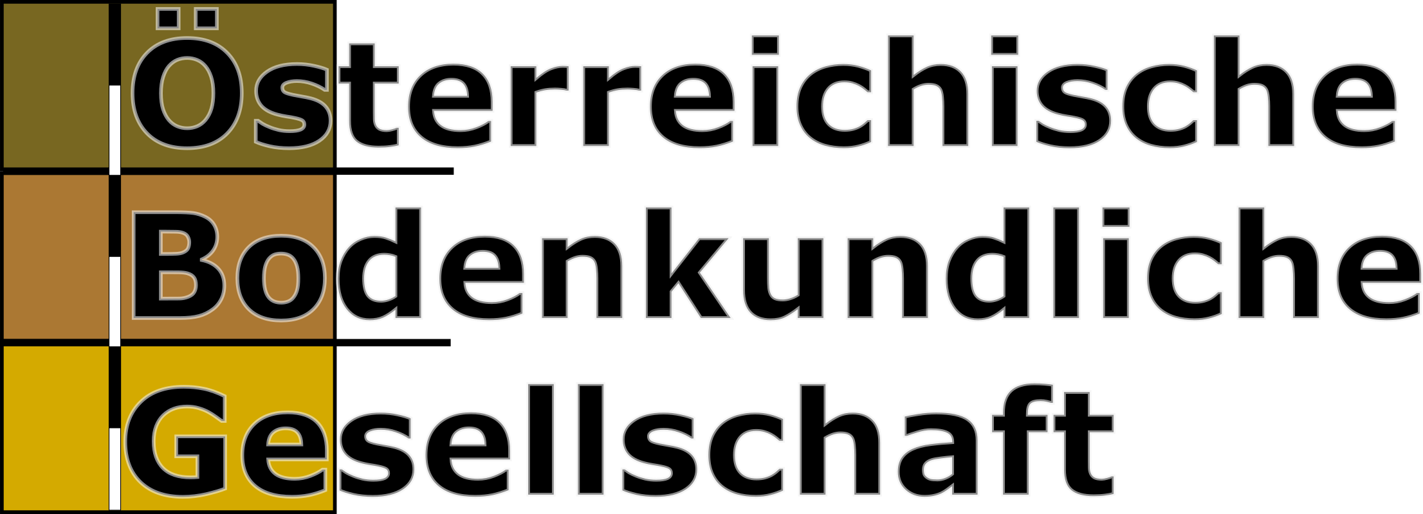

Invitation to the
Annual Meeting of the Austrian Soil Science Society 2023
on the topic
Soil Information Systems and (Digital) Soil Mapping

Friday, 29th September 2023 / 9:00 – 16:00

AGES Austrian Agency for Health and Food Safety,
Spargelfeldstraße 191, 1220 Wien, Austria

The Annual Meeting of the Austrian Soil Science Society (ÖBG) 2023 will take place on 29 September 2023 in Vienna (AGES, Spargelfeldstraße 191, 1220 Vienna). This year's event is organized in close cooperation with the project team of the WinAlp consortium under the leadership of the Department of Forest Planning of the Province of Tyrol.

Participation is free of charge for ÖBG members, as always. For non-members a participation fee of 40 € will be charged. An application for membership can be made on site (annual fee 30 €, students: 8 €).

Part of the event is a poster session with poster pitches. Poster contributions on the topic of the annual meeting are welcome, but not limited to it. All papers received and accepted in time will be published in the Book of Abstracts (as Special Issue of the “Communications of the ASSS”). Submission of papers in the form of max. one page abstracts should be in English if possible. Please send your papers by 25 August 2023 by e-mail to: michael.englisch@bfw.gv.at

Accommodation is to be booked independently if needed! Booking information including the pre-reserved room contingents can be found in the registration form. Please register as soon as possible!

Registration via Google Forms: https://tinyurl.com/2kpdn4kv

Information at https://www.bodeninfo.net/termine-und-initiativen/

Contact
Lisa Bischofer  Abteilung Forstorganisation, Land Tirol  E-Mail: l.bischofer@tirol.gv.at | Andreas Baumgarten  Österreichische Bodenkundliche Gesellschaft,  Österreichische Agentur für Gesundheit und Ernährungssicherheit GmbH (AGES)  Tel.: +43 (0) 50555 34100  E-Mail: andreas.baumgarten@ages.at

Annual Meeting of the Austrian Soil Science Society 2023
Soil Information Systems and (Digital) Soil Mapping

Program

8:30-9:00 | Arrival & Registration
9:00-9:10 | Welcome  Andreas Baumgarten, ÖBG/ASSS President | Vortragssaal A/E.51
Session 1: Soil information systems in Central Europe – different countries, similar challenges?  Chair: Sigrid Schwarz |  | Vortragssaal A/E.51
9:10-9:30 | Armin Keller – KOBO: the Swiss soil competence center | Competence Center Soil (KOBO/CCSols/CCSuolo), CH
9:30-9:50 | László Pásztor – Digital, Optimized, Soil Related Maps and Information in Hungary (DOSoReMI) | Institute for Soil Sciences and Agricultural Chemistry, Centre for Agricultural Research (ATK TAKI), HU
9:50-10:10 | Andreas Baumgarten – ABoD.at: A new platform for soil information in Austria | Institute for Sustainable Plant Production, Austrian Agency for Health and Food Safety (AGES), AT
10:10-10:30 | Q&A
10:30-10:45 | Coffee break | Foyer
Session 2: Posters  Chair: Michael Englisch |  | Vortragssaal A/E.51, Foyer
10:45-12:00 | 1-Minute poster pitches + networking with coffee + poster voting
12:00-13:00 | Lunch break with buffet | Foyer
Session 3: From plains to peaks – (Digital) Soil Mapping across varying terrain  Chair: Stefan Forstner |  | Vortragssaal A/E.51
13:00-13:20 | Brigitta Szabó – Mapping soil hydraulic properties using random-forest-based pedotransfer functions and geostatistics | Institute for Soil Sciences and Agricultural Chemistry, Centre for Agricultural Research (ATK TAKI), HU
13:20-13:40 | Robert Traidl – Soil classification and mapping in the Alps: The current state and future challenges | Bavarian Environment Agency, Marktredwitz, DE
13:40-14:00 | Q&A
14:00-14:15 | Poster awards and coffee break  Michael Englisch | Vortragssaal A/E.51, Foyer
14:15-15:30 | Discussion: Precise, easy-to-use soil information for science, policy and practice – how do we make progress?  Chair: Andreas Baumgarten  Panel: Armin Keller (CH), László Pásztor (HU), Brigitta Szabó (HU), Robert Traidl (DE), Stefan Forstner (AT)  Views from the panel (30 min)  + open discussion in the auditorium (45 min) | Vortragssaal A/E.51
15:30-16:00 | Wrap up & end of meeting  Andreas Baumgarten | Vortragssaal A/E.51

